The Tor VM Project

Installing the Build Environment & Building Tor VM

Authors: Martin Peck and Kyle Williams
Table of Contents

- Introduction and disclaimer 01
- Creating the virtualization build environment 02
  - Required downloads 02
    - VMware Player 2.5 for Windows 02
    - 20GB Linux VMware Image 02
    - Ubuntu 8.04 Desktop 02
    - Windows Driver Development Kit 02
    - DAEMON Tools Lite v4.30.1 02
  - Installing the build environment dependencies 03
    - Install VMware Player 2.5 03
    - Prepare 20GB Linux VMware Image 04
    - Building the virtual machine 05
  - Download the build script 15
- Building tor_vm.iso and w32build.iso 17
  - Get the build script and execute it 17
    - Copy the results to a Windows share 20
  - Troubleshooting 24
    - Restarting a build that broke 24
    - Some of the sources changed or are missing 24
- Using tor_vm.iso 25
  - Building Tor VM for Windows 26
    - Installing DAEMON Tools Lite 26
    - Installing Windows Driver Development Kit 33
    - Build a portable Tor VM for Windows 47
  - Using tor_vm.iso with different virtualization engines 51
- Credits and Copyrights 52
- License 53

1) Introduction and disclaimer

The operating system that was used for the production of Tor VM is Ubuntu 8.04 Desktop edition. You can install Ubuntu on to a physical computer for this process or you can use a virtual machine. Tor VM development was done inside a virtual machine. VMware Player (free) and Workstation (not-free) were used for the production of Tor VM. Other virtualization engines such as QEMU, Virtual Box, and Microsoft Virtual PC could probably be used as an alternative to VMware.

All third-party software is copyrighted to their respective companies. VMware is a registered trademark of VMware, Inc. Microsoft Windows and Driver Development Kit are registered trademarks and copyright of Microsoft Corp. Ubuntu is a registered trade mark of Canonical Ltd. These software companies may require you to agree to their respective EULA's in order to use their software.

All instructions beyond this point are based upon using VMware for the virtualization and Ubuntu 8.04 Desktop for the operating system. It should be possible to do this on other Linux based distributions and other virtualization technologies, but we make no warranty about the functionality of the final results if Tor VM is built on any other OS and/or with a different virtualization engine.

FOR ALL INTENTS AND PURPOSES, THIS SOFTWARE IS IN THE LATE ALPHA STAGES OF DEVELOPMENT. BETA AT BEST. THINGS COULD GO WRONG AND CAUSE YOUR SYSTEM TO BE MISCONFIGURED IF Tor VM CRASHES AND LEAVES YOUR SYSTEM IN AN UNUSABLE STATE. WHILE WE DO ATTEMPT TO COVER HOW TO RECOVER YOUR CONFIGURATIONS IF Tor VM CRASHES, YOU BUILD AND USE THIS AT YOUR OWN RISK!
2) Creating the virtualization build environment

There are a few different options to building an Ubuntu VM. You can download a pre-made VM from VMware website or you can build one yourself from an Ubuntu ISO. This will cover how to build one yourself.

2.1) Required Downloads

Create a directory to store the following downloads. Please download all of the requirements before you continue on with this process.

2.1.1) VMware Player 2.5 for Windows (65MB, EXE)
URL: http://download3.vmware.com/software/vmplayer/VMware-player-2.5.0-118166.exe
MD5: e94f1be6a96867419bf31e42be12f29c

2.1.2) 20GB Linux VMware Image Template (7KB, ZIP)
URL: http://www.janusvm.com/tor_vm_cache/20GB_Linux_VMware_Image.zip
MD5: 7a136c0c91d1bf34b6c657cd49d38813

2.1.3) Ubuntu 8.04 Destkop Edition (694MB , ISO)
URL: http://mirrors.us.kernel.org/ubuntu-releases/hardy/ubuntu-8.04.1-desktop-i386.iso
URL: http://www.janusvm.com/tor_vm_cache/ubuntu-8.04.1-desktop-i386.iso
MD5: c69e34e92d5402d1b87e6babc739f774

2.1.4) Windows Driver Development Kit (230MB, ISO)
URL: http://download.microsoft.com/download/9/0/f/90f019ac-8243-48d3-91cf-81fc4093ecfd/1830_usa_ddk.iso
MD5: e9193a1e80c3dd13b66af81d4fbb9369

2.1.5) DAEMON Tools Lite v4.30.1 (496KB, EXE)
URL: http://www.disc-tools.com/request?p=8893e3cf57305128d9b26f48f7ac9a50/daemon347.exe
MD5: fe36ef3abf2589bef67f0113f40ff845

2.1.6) Windows XP or Server 2003

2.2) Installing the build environment dependencies

2.2.1) Install VMware Player 2.5

Open the directory that you saved the downloads to, and launch
Vmware-player-2.5.0-118166.exe.

If you get Security Warning asking you “Do you want to run this file?”, click on “Run”.

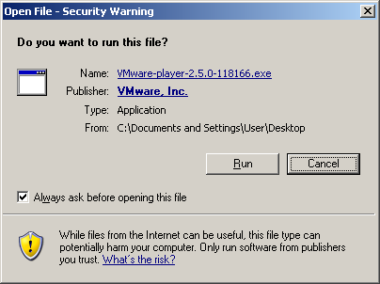
Follow the instructions VMware provides with their installer. If you ever installed an application on Windows before, then installing VMware should not be a problem for you.

If you've never installed an application in Windows before, then just remember the following. Click on anything that says “Next”, “I accept ....”, “Yes”, “Agree” and/or “OK”. That's sums it up in a nut shell.

2.2.2) Prepare 20GB Linux VMware Image

Extract the previously downloaded 20GB_Linux_VMware_Image.zip file into a new directory. Move the ubuntu-8.04.1-desktop-i386.iso into the same directory that you extracted the 20GB Linux VMware Image contents to.

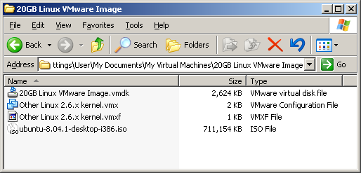
2.2.3) Building the virtual machine

Now launch the VM by opening “Other Linux 2.6.x kernel.vmx”. This will boot the VM from the ubuntu-8.04.1-desktop-i386.iso.

NOTE: You will have to agree to VMware's EULA before you can use their software.

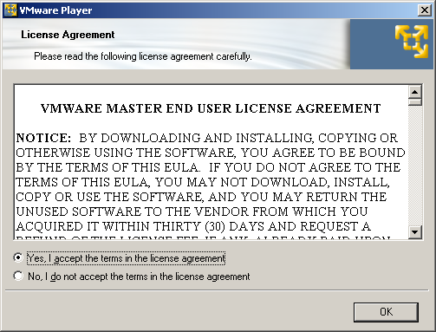

When Ubuntu boot's, choose your language setting then select “Install Ubuntu”.

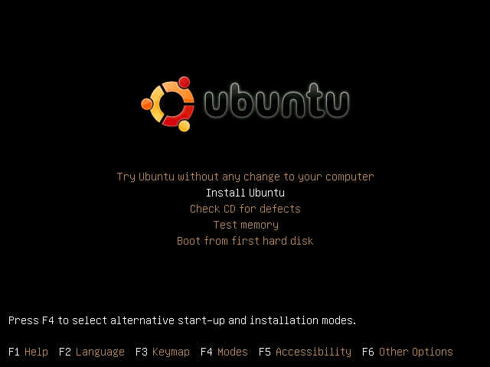

At step 1, select your language and click “Forward”.

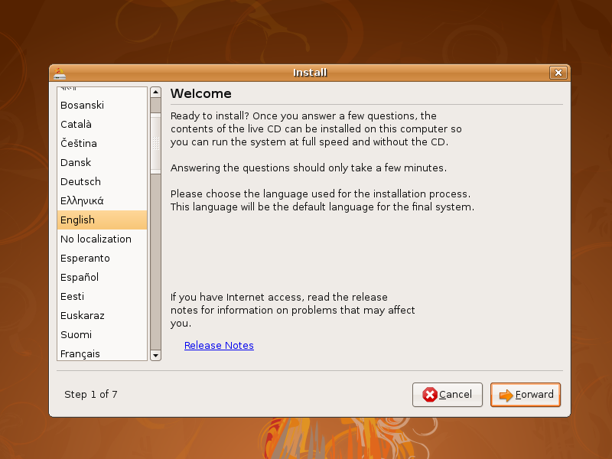

At step 2, select your time zone and click “Forward”.

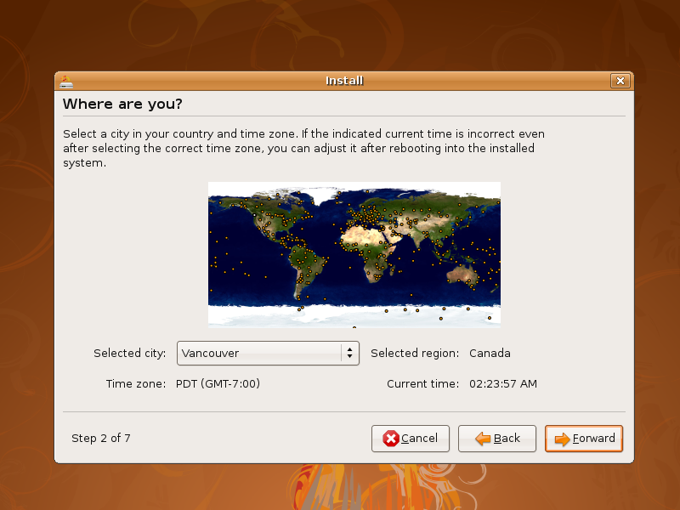

At step 3, pick a keyboard layout that best suites your needs and click “Forward”.

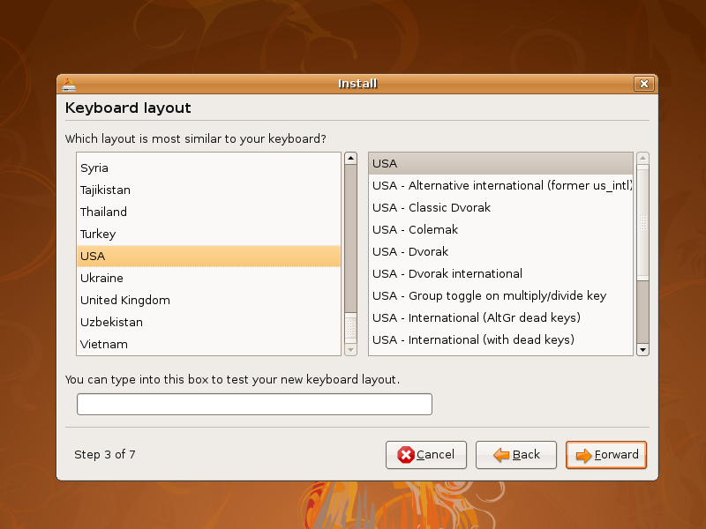

At step 4, make sure that “Guided – use entire disk” and “SCSI 1 (0,0,0) (sda) “ are selected and click “Forward”.

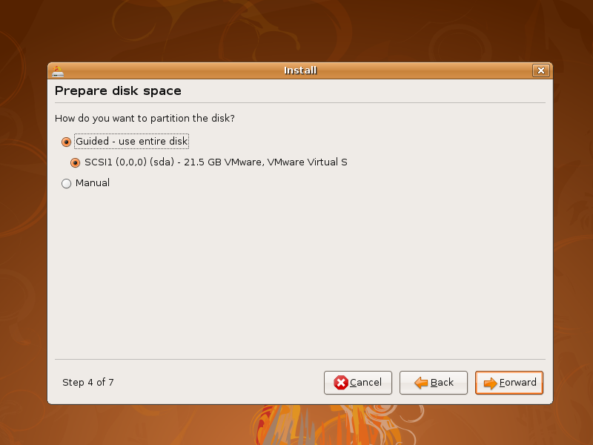

At step 5, pay close attention.
When asked “What is your name?”, type “Guest”.
When asked “What name do you want to use to log in?”, type “guest”
When asked to “Choose a password to keep your account safe.”, pick a password.
Click on “Forward”.
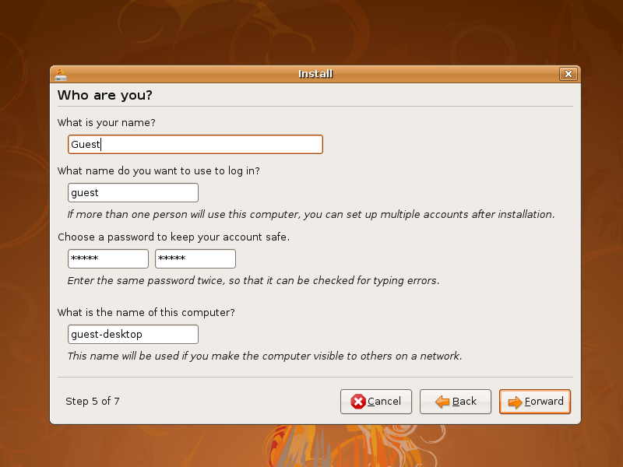

At step 7, click “Install”

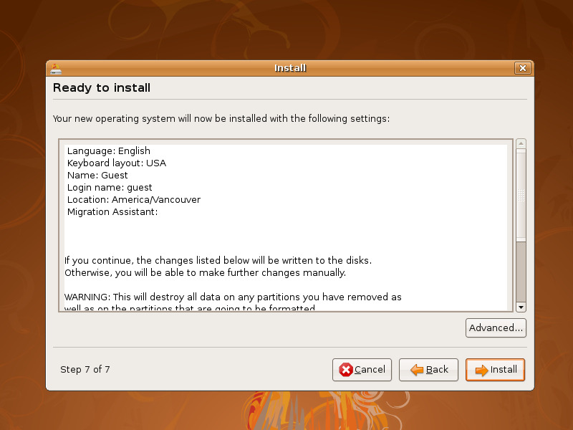

When the installation is finished, you will see a “Installation complete” window inside the VM window. Click on the “Reboot Now” button.

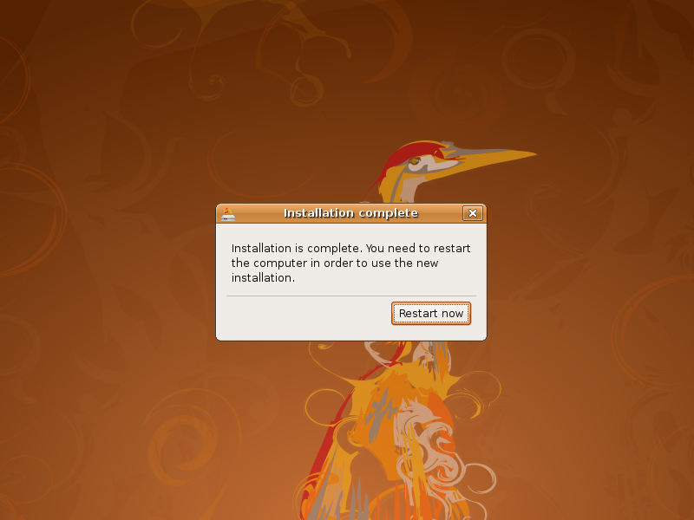

At the black shutdown screen, hit enter one more time to make the VM reboot.

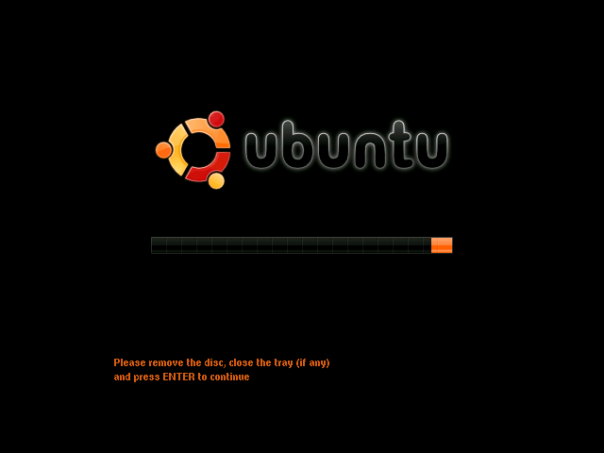

You have now installed Ubuntu 8.04 Desktop in a VM. This will be your build environment for Tor VM.

2.3) Download the build script

Now that you have finished installing Ubuntu, you will need to download the build script for Tor VM. Start by logging into your new VM. You will have to type in your username and password.

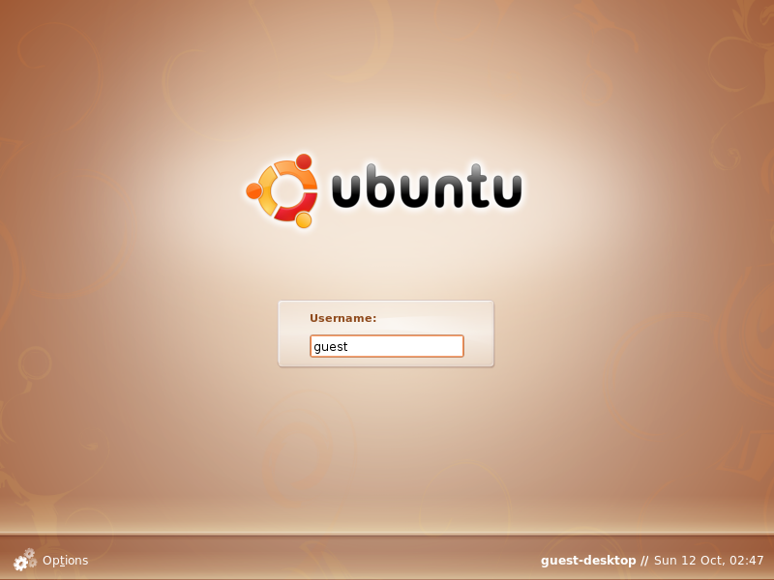

Open up a Terminal session. You can start a Terminal session by going to the “Applications” menu, then “Accessories”, and then “Terminal”.

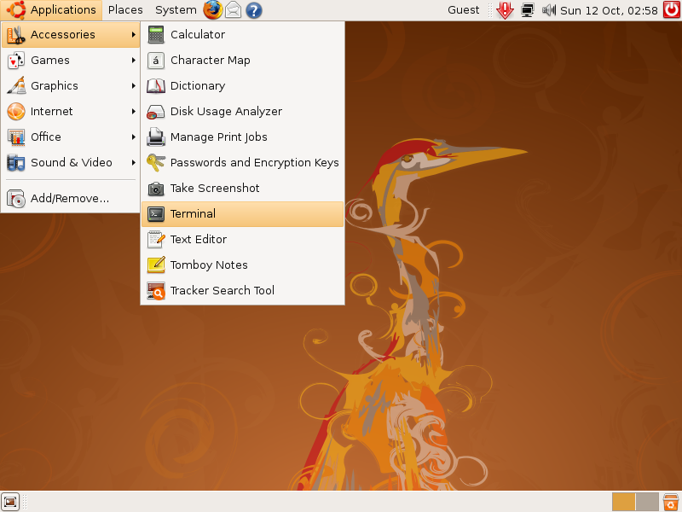
3) Building tor_vm.iso and w32build.iso

3.1) Get the build script and execute it

Now that you have downloaded, installed, and configured Ubuntu, you are ready to build the ISO images for Tor VM. Type in the following commands in the Terminal.

> sudo su -
(enter the password you set for the “guest” user)
> mkdir /build
> cd /build
> wget www.janusvm.com/tor_vm_cache/build-Tor VM.sh

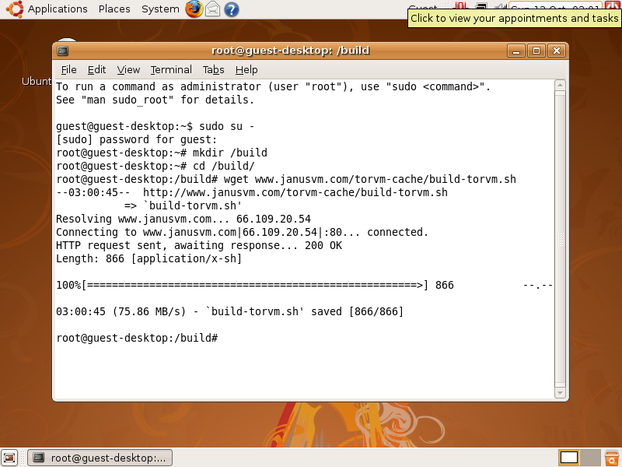

> chmod +x build-Tor VM.sh
> ./build-Tor VM.sh

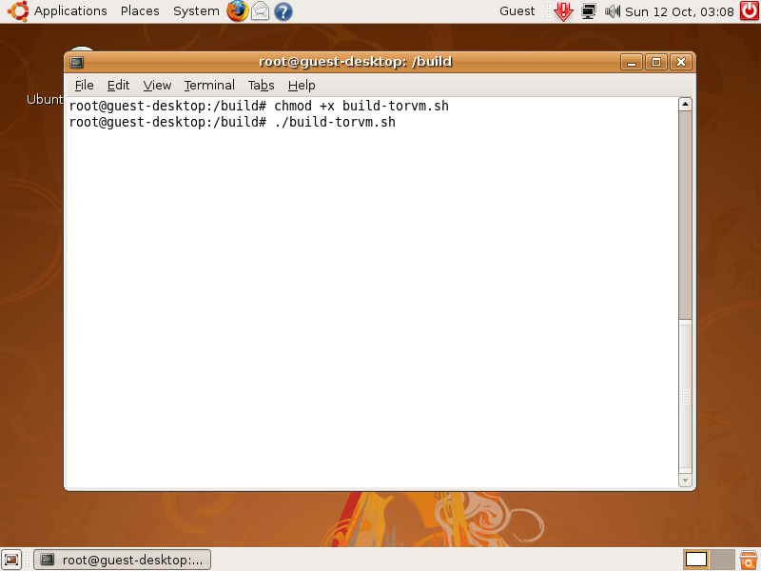

This will start your build process which will take a couple of hours to complete. The build process will download and install any necessary tools that are required to build Tor VM. After the tools have been installed, the Tor VM source code is downloaded and SHA-1 checksums of the source code are checked. If the checksums pass, then Tor VM is compiled.

When the build is complete, it should bring you back to the command prompt with no errors.

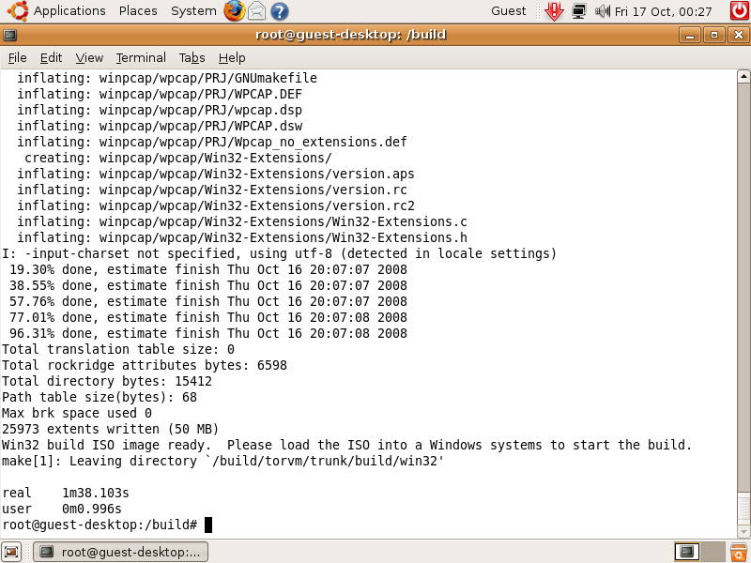
3.1.1) Copy the results to a Windows Share

Now we must copy the created ISO images over to a Windows XP machine, or VM. In order to do that, we must share a directory.

Create a folder called “ISO”.
Right-click on the ISO folder and select “Sharing and Security...”.

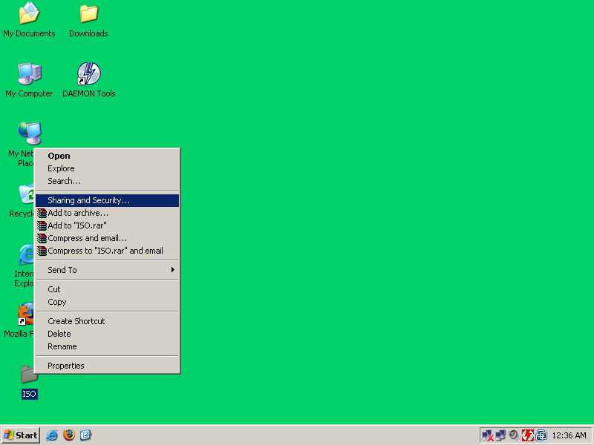

Check the “Share this folder on the network” box.
Check the “Allow network users to change my files” box.
Click on “Apply” then click on “OK”.

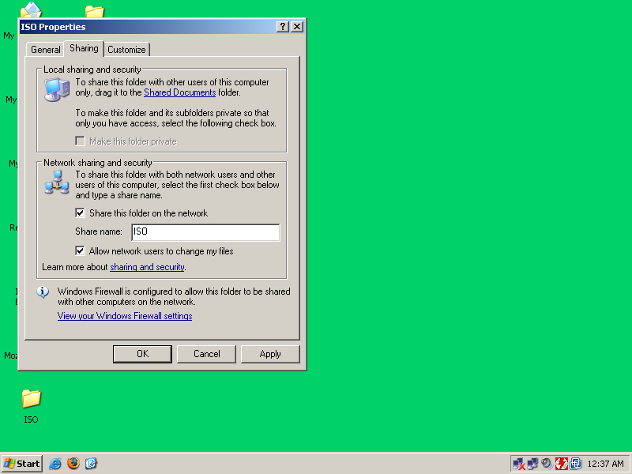

Now that your ISO folder on Windows is shared, the ISO images can be copied over. In order to do this we mount the windows share to a directory in Ubuntu. Login as root and do the following commands.

(NOTE! Use the IP address of your Windows computer or VM, not 192.168.1.4 unless that is your Windows IP.)

> cd /mnt/
> mkdir iso
> mount -t smbfs //192.168.1.4
(Type in your password on your Windows computer)
> cp /build/torvm/trunk/build/iso/vm.iso iso/tor_vm.iso
> cp /build/torvm/trunk/build/win32/w32build.iso iso/tor_vm.iso

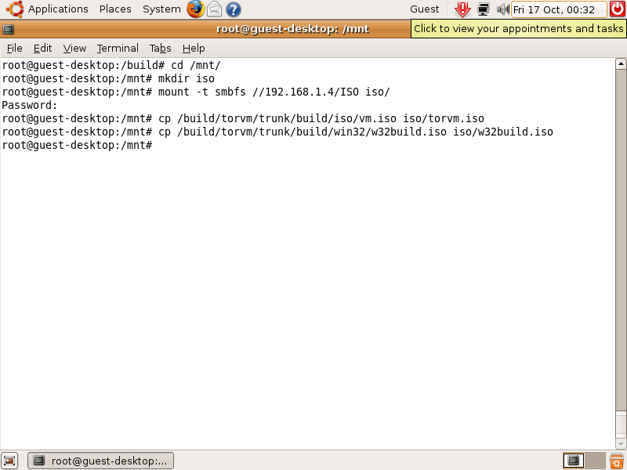

If all goes well, you should now have the tor_vm.iso and the w32build.iso on your Windows computer.

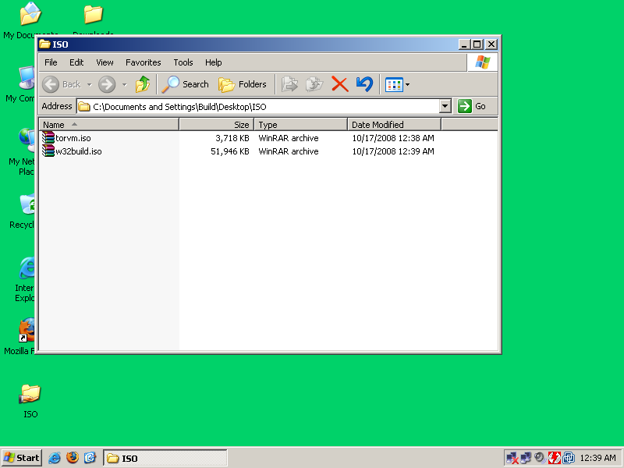
3.2) Troubleshooting

Tor VM uses open software that has to be downloaded from various different locations on the Internet. Sometimes those sites change their directory structure, go down for maintenance, or simply just timeout. When this happens, the build scripts do not handle it very well. As a result of this, you may have to manually start the build from where it broke.

3.2.1) Restarting a build that broke

According to the build script, your build directory is /build/torvm/trunk. You can simply change to this directory and restart the build.

> cd /build/torvm/trunk
> make

3.2.2) Some of the sources changed or are missing

The are many possible things that can go wrong when your software build depends on several different pieces of software. The good news is that there is an online cache of all the open source files that are used in this project. If you download the cached files, you must reconfigure your build instance to use it. The following commands show how to download the cache, reconfigure the build instance, and restart the build.

> cd /build/torvm/trunk/build/kamikaze/common/dl
> wget -R http://www.janusvm.com/tor_vm_cache/dl/
> cd ../../../win32/dl
> wget -R http://www.janusvm.com/tor_vm_cache/wdl/
> cd ../../..
> chown -R guest.users *
> make

4) Using tor_vm.iso

You can use Tor VM in a couple of different ways. The recommended way is to build a portable Tor VM for Microsoft Windows. You can also use VMware or any virtualization engine that supports bridged, or raw, network interfaces. The version of QEMU that is built in this process has been modified to be able to support a emulating a raw Ethernet device through your existing NIC. Sun's VirtualBox or Microsoft's Virtual PC may be able to do this too.

You can build a portable version of Tor VM that uses QEMU for the virtualization engine and a modified WinPCAP driver with a OpenVPN Tap32 adapter for the bridged or raw Ethernet networking. The following sections will walk you through how to build a portable version of Tor VM for Microsoft Windows XP. This has only been tested on Windows XP.

4.1) Building Tor VM for Windows

This documentation will cover how to install all the required tools and dependencies in order to create a portable version of Tor VM.

4.1.1) Installing DAEMON Tools Lite

The Ubuntu build stage creates ISO's that need to either be burned to CD or mounted using a third party program. For the development of Tor VM, DAEMON Tools Lite was used to mount ISO images as a CD-ROM device under My Computer.

You should already have daemon347.exe from downloading the software in section 2.1. Run daemon347.exe to install DAEMON Tools Lite.

If you see a security warning, click on “Run”

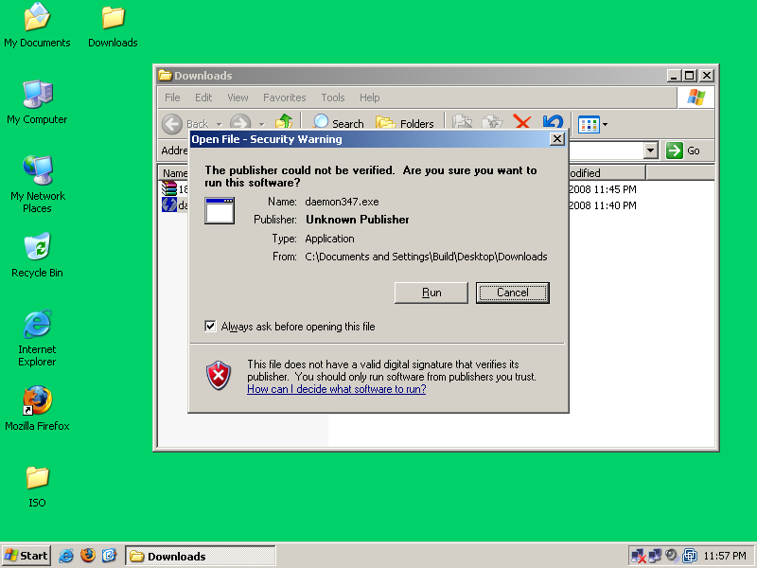

You will then be prompted with and EULA, click on “Install”.

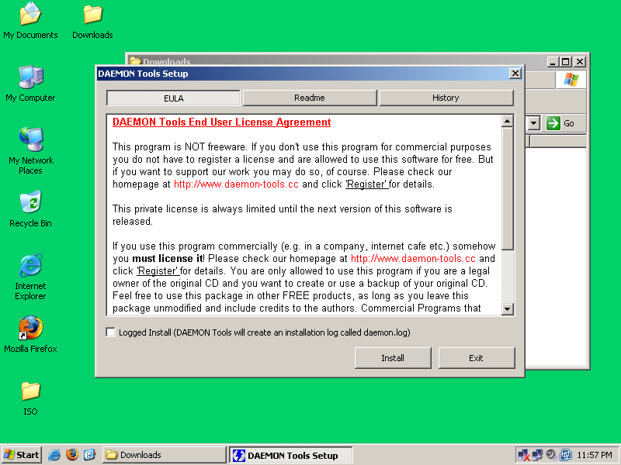

Click on “Next”.

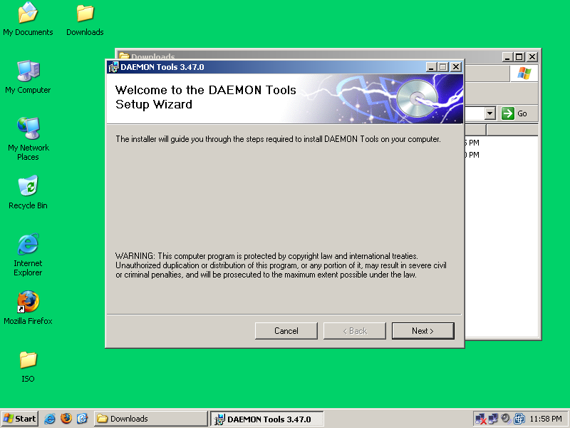

Click on “Next”.

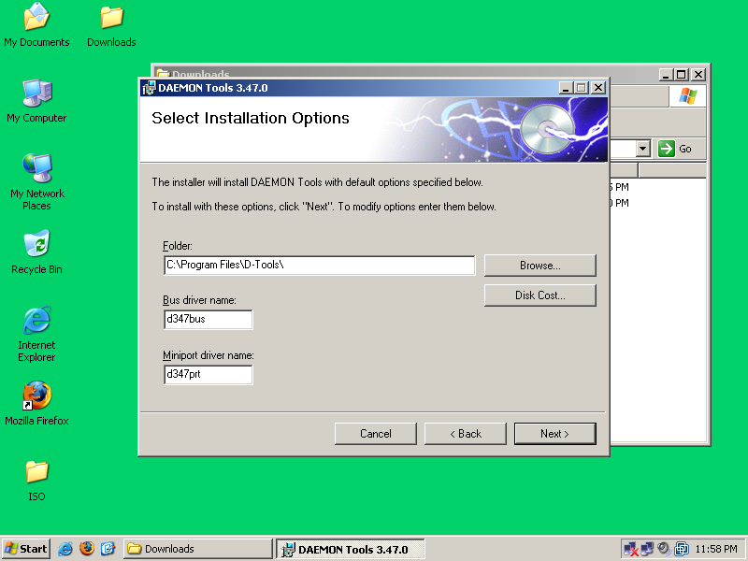

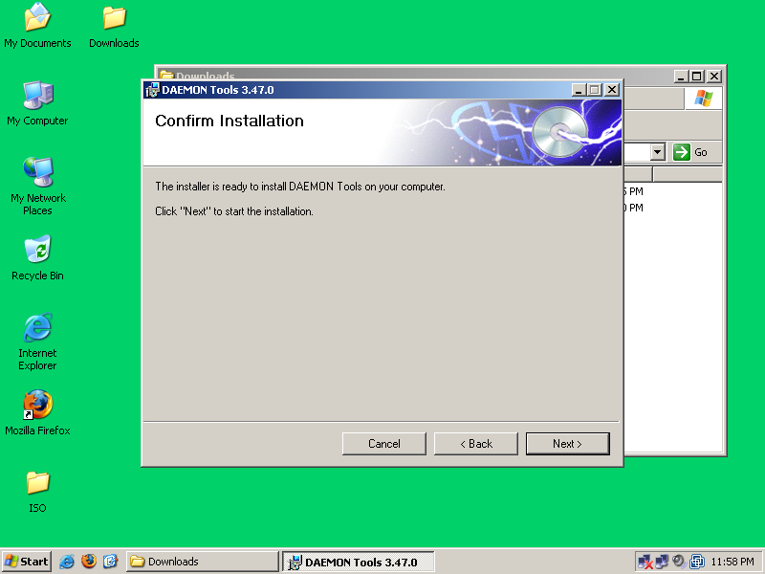
Click on “Next”.

After DAEMON Tools has finished installing, click on “Close”.

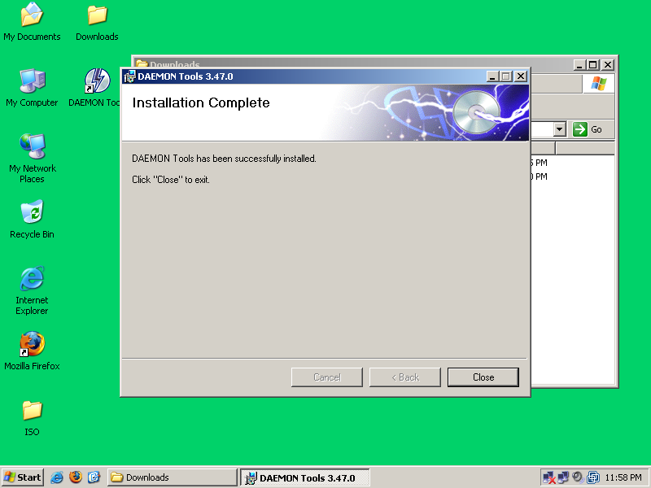

You will then be prompted to restart your computer, click “Yes”. Your computer will reboot.

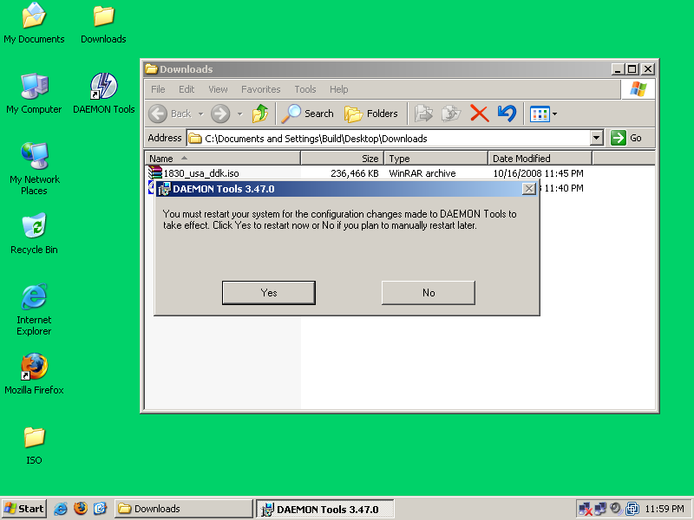
After your computer or VM has rebooted, DAEMON Tools will be installed and running.
4.1.2) Installing Windows Driver Development Kit

In order to build the drivers that are required, you need to install the Windows Driver Development Kit. You will have to use DAEMON Tools or burn the ISO to a CD in order to do this. The following is how to install the Windows DDK with DAEMON Tools.

Left-click the red lighting bolt in the lower left corner and click on “Device 0: [E:] No media”.

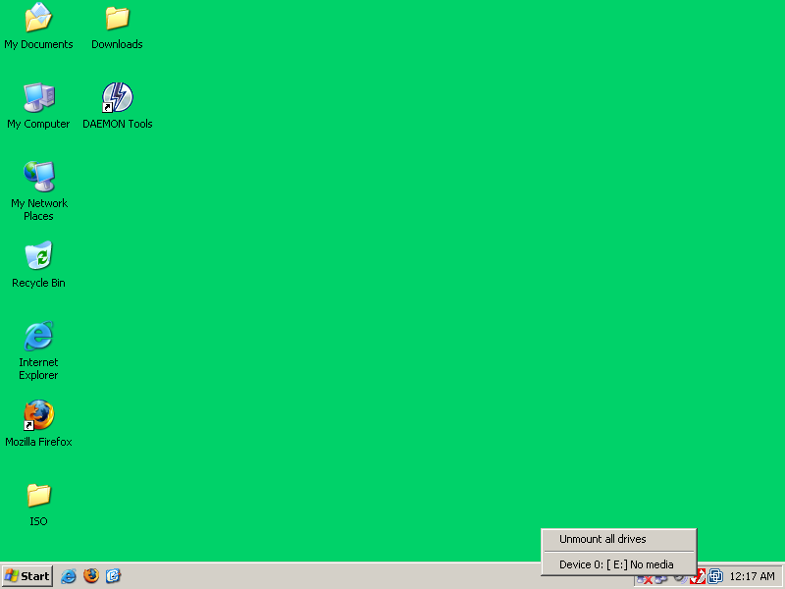

Goto the folder that you downloaded the Windows Driver Development Kit ISO to.
Select “1830_usa_ddk.iso” and click “Open”.

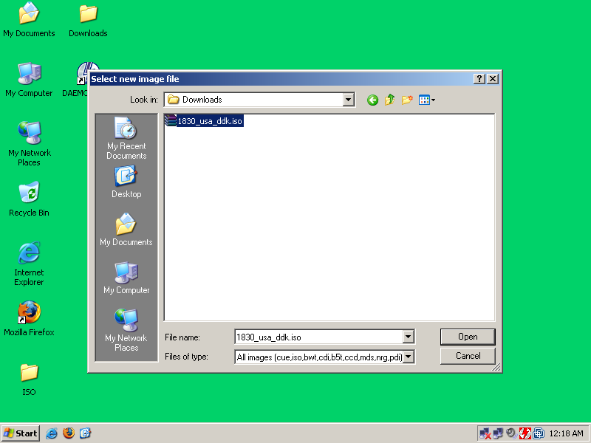

If autorun is enabled on Windows, then the ISO will be mounted as a CD and will open some of Microsoft's legal babel. Just close the browser window.

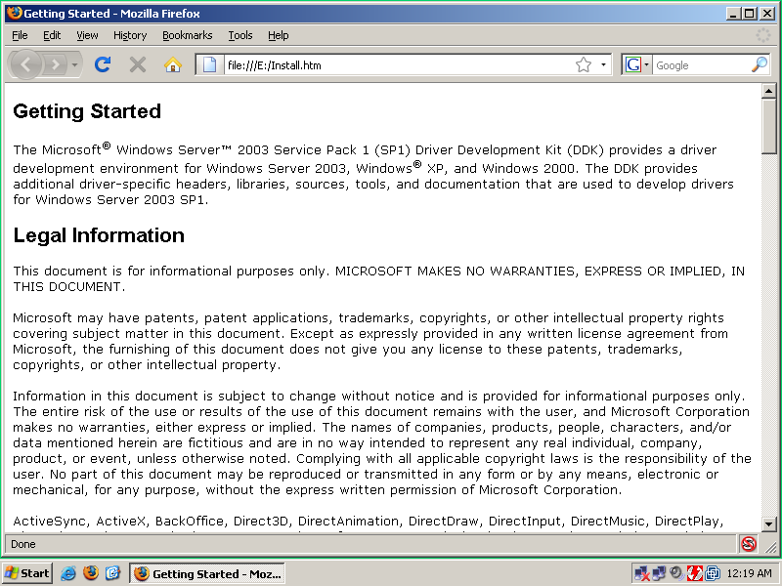

Right-click on “My Computer” and select “Explore”.

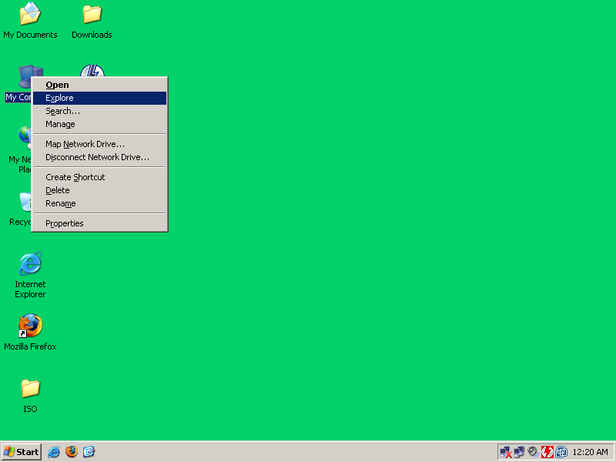

DAEMON Tools mount the ISO image as the “E:” drive under My Computer.

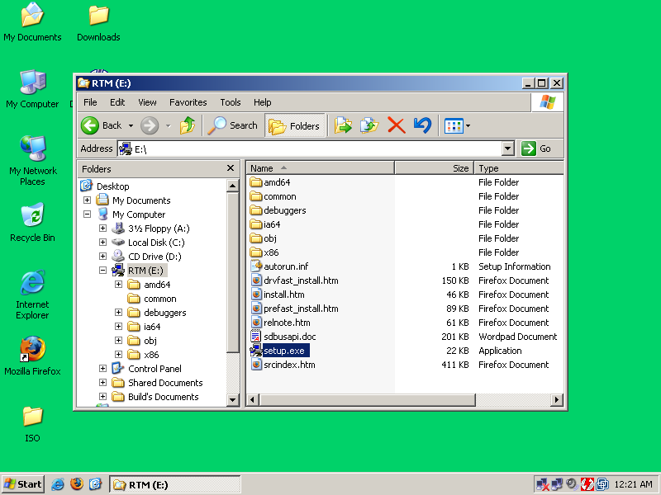

Right-click on “setup.exe” and select “Open”.

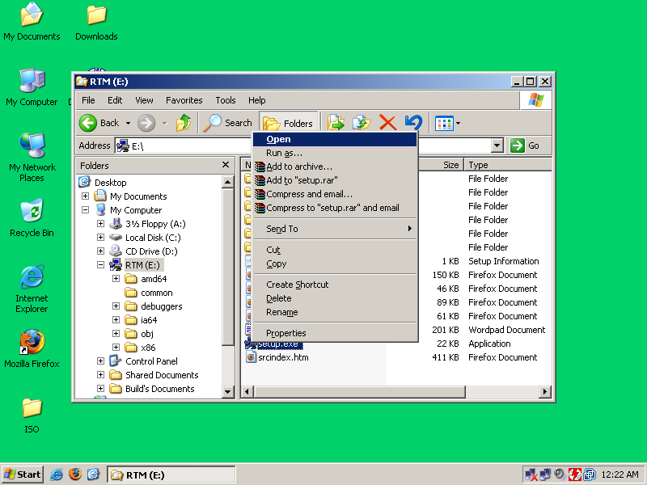

The Microsoft Windows Driver Development Kit installation is fairly simple.
Click on “Next”.

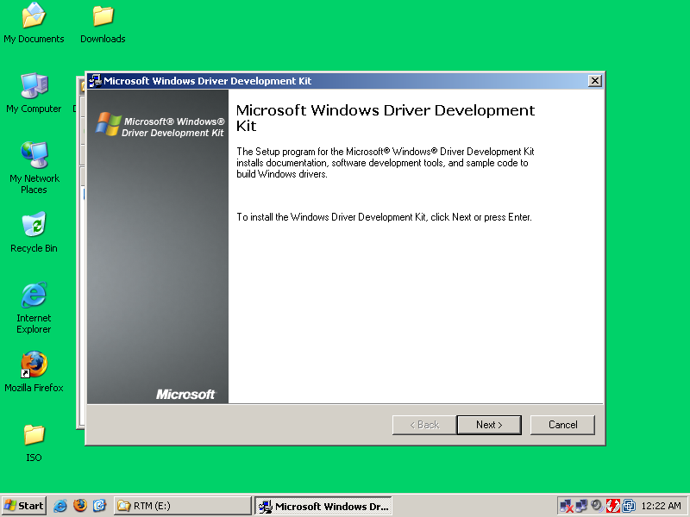

Select “I Agree” and click on “Next”.

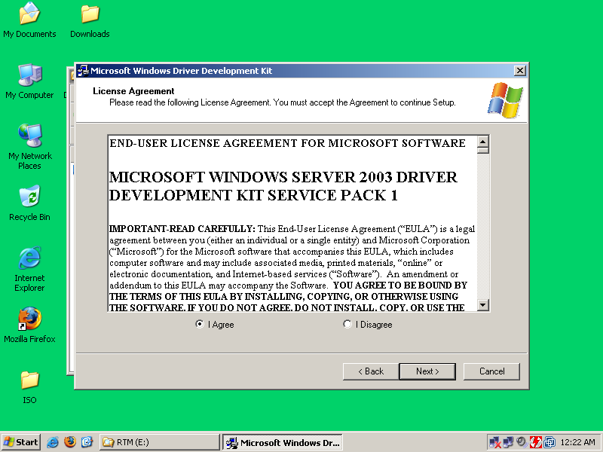

Click on “Next”.

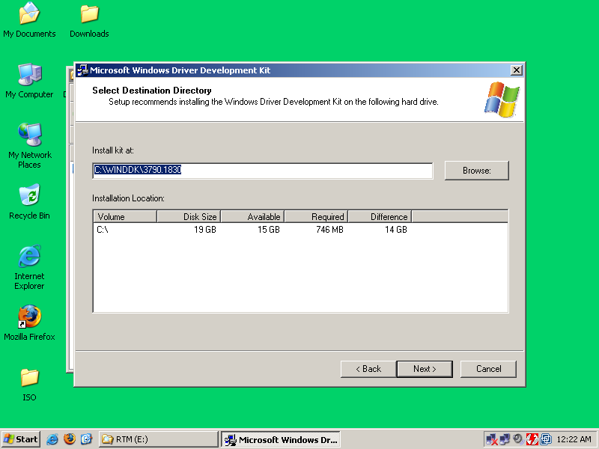

Click on “Next”.

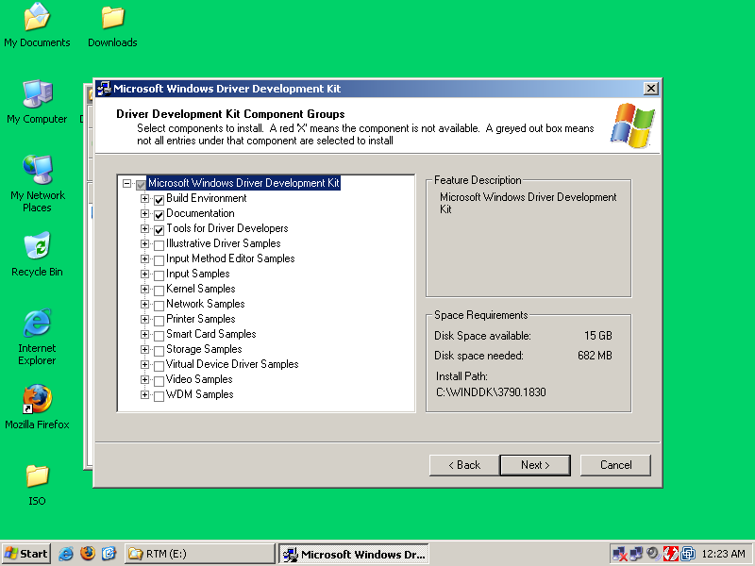

Click on “Next”.

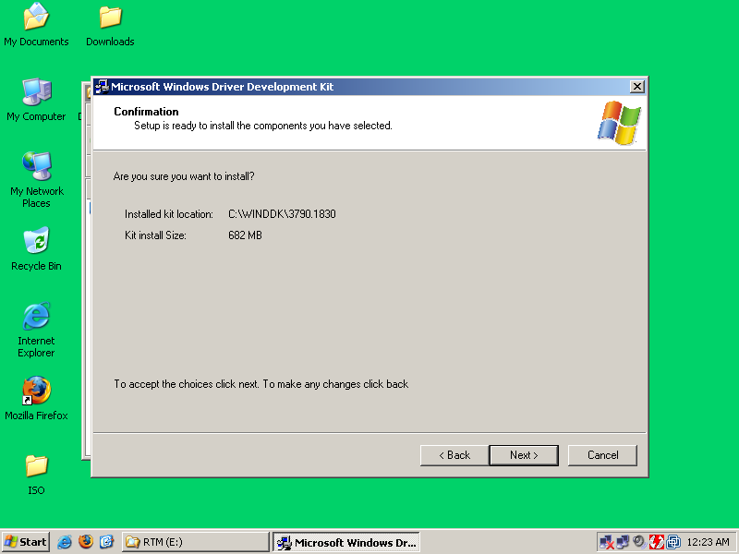

The installation will take a couple of minutes. Install times will be relative to the speed of your computer.

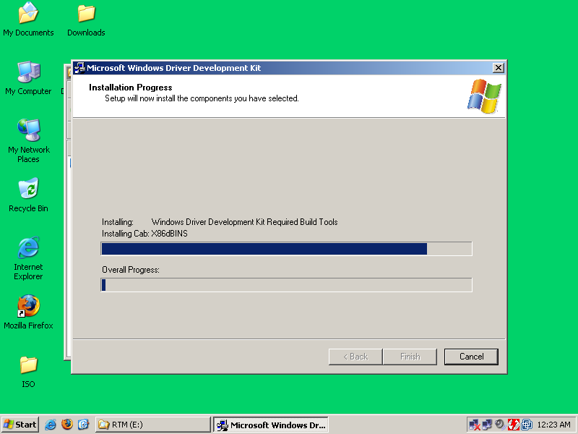

When the installation is complete, click on “Finish”.

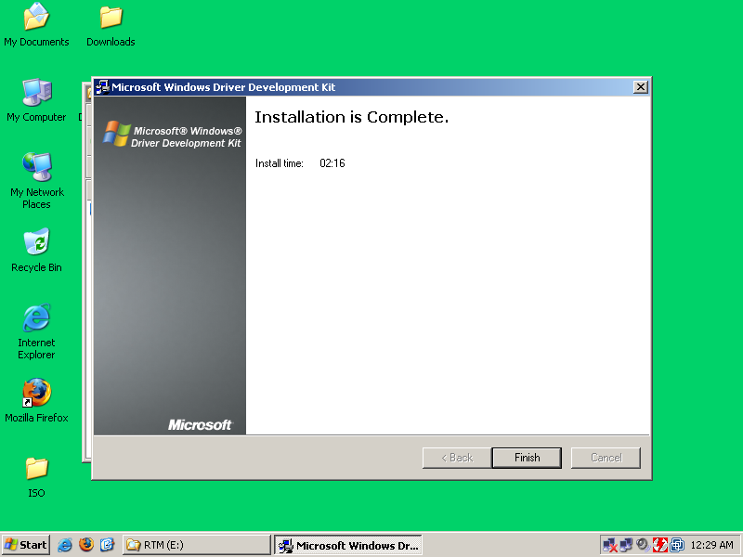
You have now installed the Microsoft Windows Driver Development Kit.

Next you must unmount the ISO image. Left-click on the red lighting bolt and select “Unmount all drives”.

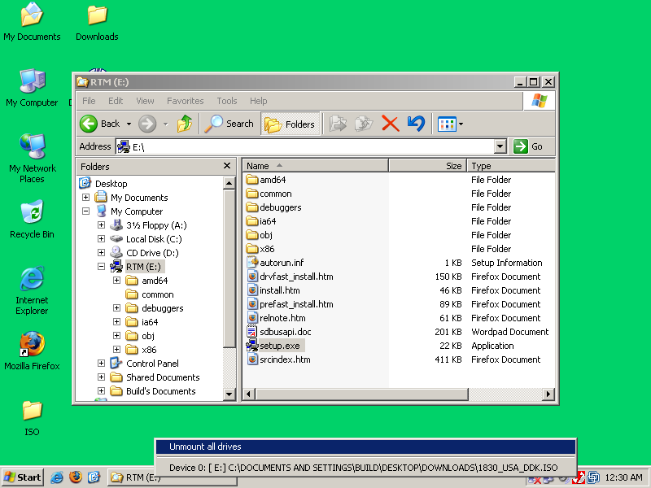
4.1.3) Build a portable Tor VM for Windows

Now that the Windows DDK has been installed, you can build the portable Windows version.

Left-click on the DAEMON Tools icon (red electric bolt) in the lower left corner of the screen, and choose “Device 0: [E:] No Media”.

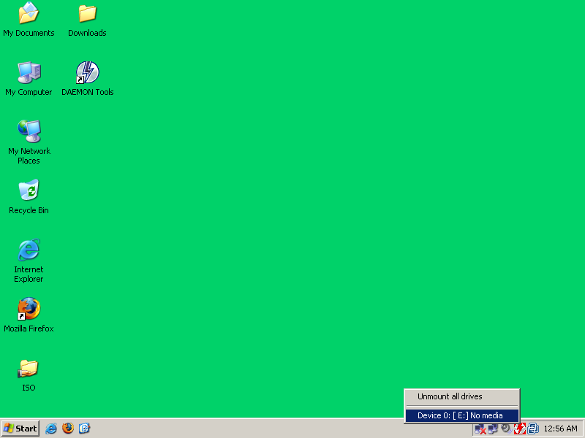

Select the “w32build.iso” file that you copied over earlier, and click “Open.”.

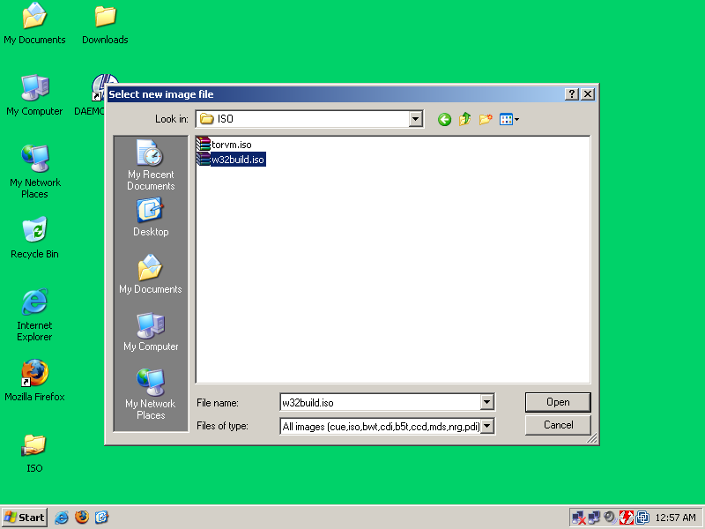

If you have autorun enabled, the build will start automatically.

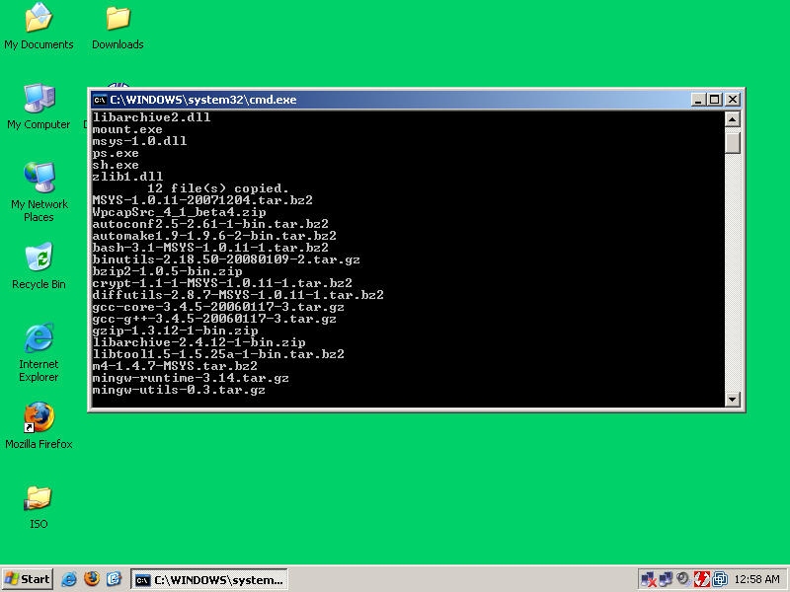

If you do not have autorun enabled, then you will have to open the “install.bat” under the mounted ISO image (E Drive). This will launch a build of the portable Tor VM for Windows.

When the build is complete, you can find the final results in C:\Tor_VM.

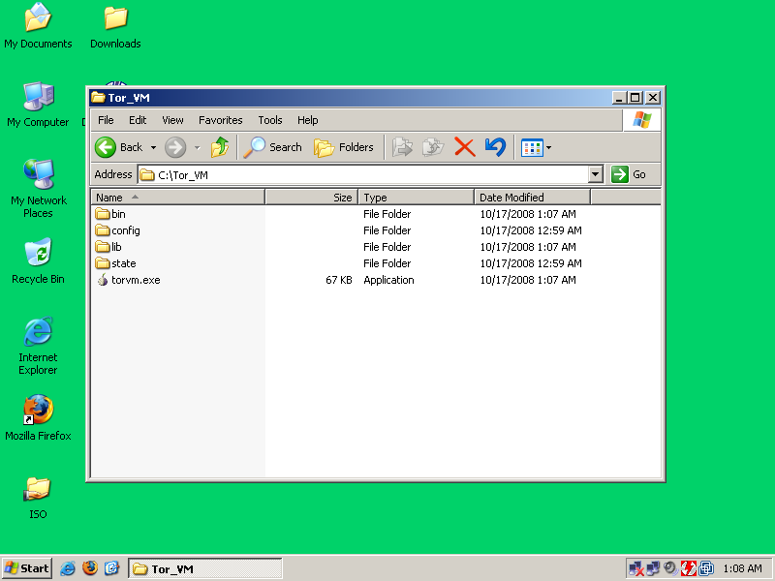

That's it. You now have a virtual machine that routes all your DNS requests and TCP traffic through Tor. To use Tor VM, just open “Tor VM.exe”. Please refer to the Tor VM – Usage document for usage instructions.

4.2) Using tor_vm.iso with different virtualization engines.

(To be done)
5) Credits and Copyrights

“Tor” and the “Onion Logo” are registered trademark of The Tor Project, Inc. Microsoft Windows is copyrighted and a registered trademark of Microsoft Corp. VMware Player, Server, and Workstation are copyrighted and a registered trademark of VMware, Inc. QEMU is a trademark of Fabrice Bellard.

6) License

Tor VM is distributed under this license:

Copyright (c) 2001-2004, Roger Dingledine
Copyright (c) 2004-2006, Roger Dingledine, Nick Mathewson
Copyright (c) 2007-2008, The Tor Project, Inc.

Redistribution and use in source and binary forms, with or without
modification, are permitted provided that the following conditions are
met:

* Redistributions of source code must retain the above copyright
notice, this list of conditions and the following disclaimer.

* Redistributions in binary form must reproduce the above
copyright notice, this list of conditions and the following disclaimer
in the documentation and/or other materials provided with the
distribution.

* Neither the names of the copyright owners nor the names of its
contributors may be used to endorse or promote products derived from
this software without specific prior written permission.

THIS SOFTWARE IS PROVIDED BY THE COPYRIGHT HOLDERS AND CONTRIBUTORS
"AS IS" AND ANY EXPRESS OR IMPLIED WARRANTIES, INCLUDING, BUT NOT
LIMITED TO, THE IMPLIED WARRANTIES OF MERCHANTABILITY AND FITNESS FOR
A PARTICULAR PURPOSE ARE DISCLAIMED. IN NO EVENT SHALL THE COPYRIGHT
OWNER OR CONTRIBUTORS BE LIABLE FOR ANY DIRECT, INDIRECT, INCIDENTAL,
SPECIAL, EXEMPLARY, OR CONSEQUENTIAL DAMAGES (INCLUDING, BUT NOT
LIMITED TO, PROCUREMENT OF SUBSTITUTE GOODS OR SERVICES; LOSS OF USE,
DATA, OR PROFITS; OR BUSINESS INTERRUPTION) HOWEVER CAUSED AND ON ANY
THEORY OF LIABILITY, WHETHER IN CONTRACT, STRICT LIABILITY, OR TORT
(INCLUDING NEGLIGENCE OR OTHERWISE) ARISING IN ANY WAY OUT OF THE USE
OF THIS SOFTWARE, EVEN IF ADVISED OF THE POSSIBILITY OF SUCH DAMAGE.
===============================================================================
src/common/strlcat.c and src/common/strlcpy.c by Todd C. Miller are licensed
under the following license:

* Copyright (c) 1998 Todd C. Miller <Todd.Miller@courtesan.com>
* All rights reserved.
*
* Redistribution and use in source and binary forms, with or without
* modification, are permitted provided that the following conditions
* are met:
* 1. Redistributions of source code must retain the above copyright
* notice, this list of conditions and the following disclaimer.
* 2. Redistributions in binary form must reproduce the above copyright
* notice, this list of conditions and the following disclaimer in the
* documentation and/or other materials provided with the distribution.
* 3. The name of the author may not be used to endorse or promote products
* derived from this software without specific prior written permission.
*
* THIS SOFTWARE IS PROVIDED ``AS IS'' AND ANY EXPRESS OR IMPLIED WARRANTIES,
* INCLUDING, BUT NOT LIMITED TO, THE IMPLIED WARRANTIES OF MERCHANTABILITY
* AND FITNESS FOR A PARTICULAR PURPOSE ARE DISCLAIMED. IN NO EVENT SHALL
* THE AUTHOR BE LIABLE FOR ANY DIRECT, INDIRECT, INCIDENTAL, SPECIAL,
* EXEMPLARY, OR CONSEQUENTIAL DAMAGES (INCLUDING, BUT NOT LIMITED TO,
* PROCUREMENT OF SUBSTITUTE GOODS OR SERVICES; LOSS OF USE, DATA, OR PROFITS;
* OR BUSINESS INTERRUPTION) HOWEVER CAUSED AND ON ANY THEORY OF LIABILITY,
* WHETHER IN CONTRACT, STRICT LIABILITY, OR TORT (INCLUDING NEGLIGENCE OR
* OTHERWISE) ARISING IN ANY WAY OUT OF THE USE OF THIS SOFTWARE, EVEN IF
* ADVISED OF THE POSSIBILITY OF SUCH DAMAGE.

===============================================================================
If you got Tor as a static binary with OpenSSL included, then you should know:
"This product includes software developed by the OpenSSL Project
for use in the OpenSSL Toolkit (http://www.openssl.org/)"
===============================================================================
"This program uses the IP-to-Country Database provided by
WebHosting.Info (http://www.webhosting.info), available from
http://ip-to-country.webhosting.info."
See the src/config/geoip file in particular.
===============================================================================

